

**MEMORANDUM OF UNDERSTANDING**

This is a document validating an agreement between **MR. OGABOR JOHN AND MR. LUKE BAMTEFA** for the collaborative of 20% interest over a sum of **ONE HUNDRED THOUSAND NAIRA ONLY (N100000) paid on the 11th of May, 2020.**

There is a binding agreement to pay the initial capital invested, alongside the interest, **ONE HUNDRED AND TWENTY THOUSAND NAIRA ONLY (N120000) on the 10th of June, 2020** by **MR. OGABOR JOHN TO MR. LUKE BAMTEFA.**

Attached with this document is an evidence of payment by **MR. LUKE BAMTEFA.**

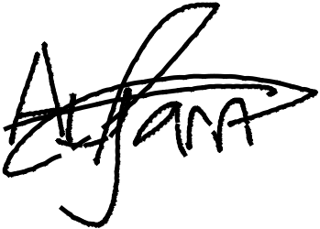

_________________________

_~~__~~_____~~___~~_~~_~~___________



**MR. LUKE BAMTEFA**

**MR. OGABOR JOHN**

***(CEO, JOHN INVESTMENTS)***